Title: Skin Disease Predictor using Transfer Learning in CNN
Done by : Pritesh Ram Keshri Project Number : 06, Submission Date: 19th June 2025
Overview:

This project demonstrates an image classification system designed to predict various skin diseases using Convolutional Neural Networks (CNN) and the Transfer Learning approach. The model leverages pre-trained weights and has been trained on a labeled image dataset sourced from the DermNet dataset.

Libraries used:

- TensorFlow/Keras – Model creation, training, and prediction
- NumPy – Efficient array operations
- Glob – Accessing image file paths for training
- Matplotlib – Visualization and analysis of model performance

Dataset Details:

- Source: DermNet Skin Disease Dataset
- Format: Image classification dataset
- Classes: Multiple skin disease categories such as eczema, psoriasis, acne, etc.
- Structure: Labeled image folders compatible with Keras’ flow_from_directory function

APIs Integrated:

No external APIs integrated.
Source code 1: File Name : Data Preprocessing (preprocess.py)

import os
import glob
import numpy as np
from tensorflow.keras.preprocessing.image import ImageDataGenerator

# Set image size and path
IMG_SIZE = (224, 224)
BATCH_SIZE = 32

# Data generators for training and validation
train_datagen = ImageDataGenerator(rescale=1./255, validation_split=0.2)

train_data = train_datagen.flow_from_directory(
'dataset/',
target_size=IMG_SIZE,
batch_size=BATCH_SIZE,
class_mode='categorical',
subset='training'
)

val_data = train_datagen.flow_from_directory(
'dataset/',
target_size=IMG_SIZE,
batch_size=BATCH_SIZE,
class_mode='categorical',
subset='validation'
)
Source code 2: File name: Model Architecture & Training (train_model.py)

from tensorflow.keras.applications import MobileNetV2
from tensorflow.keras import layers, models

# Load base model with pre-trained weights
base_model = MobileNetV2(weights='imagenet', include_top=False, input_shape=(224, 224, 3))
base_model.trainable = False # Freeze layers

# Build the complete model
model = models.Sequential([
base_model,
layers.GlobalAveragePooling2D(),
layers.Dense(128, activation='relu'),
layers.Dropout(0.3),
layers.Dense(train_data.num_classes, activation='softmax')
])

# Compile the model
model.compile(optimizer='adam', loss='categorical_crossentropy', metrics=['accuracy'])

# Train the model
model.fit(train_data, validation_data=val_data, epochs=10)
Source code 3: Evaluation & Visualization (evaluate.py)

import matplotlib.pyplot as plt

# Evaluate the model
loss, accuracy = model.evaluate(val_data)
print(f"Validation Accuracy: {accuracy * 100:.2f}%")

# Plot training history
def plot_history(history):
plt.figure(figsize=(12, 4))

# Accuracy
plt.subplot(1, 2, 1)
plt.plot(history.history['accuracy'], label='Train Accuracy')
plt.plot(history.history['val_accuracy'], label='Val Accuracy')
plt.title('Model Accuracy')
plt.legend()

# Loss
plt.subplot(1, 2, 2)
plt.plot(history.history['loss'], label='Train Loss')
plt.plot(history.history['val_loss'], label='Val Loss')
plt.title('Model Loss')
plt.legend()

plt.show()
Source Code 4: Prediction Interface (predict.py)

import numpy as np
from tensorflow.keras.preprocessing import image

# Load model
from tensorflow.keras.models import load_model
model = load_model('skin_disease_model.h5')

# Predict single image
def predict_image(img_path):
img = image.load_img(img_path, target_size=(224, 224))
img_array = image.img_to_array(img) / 255.0
img_array = np.expand_dims(img_array, axis=0)

prediction = model.predict(img_array)
predicted_class = np.argmax(prediction)

return predicted_class

Output screenshots:

1. Model Architecture Summary: Shows the complete structure of the transfer learning model and custom layers.
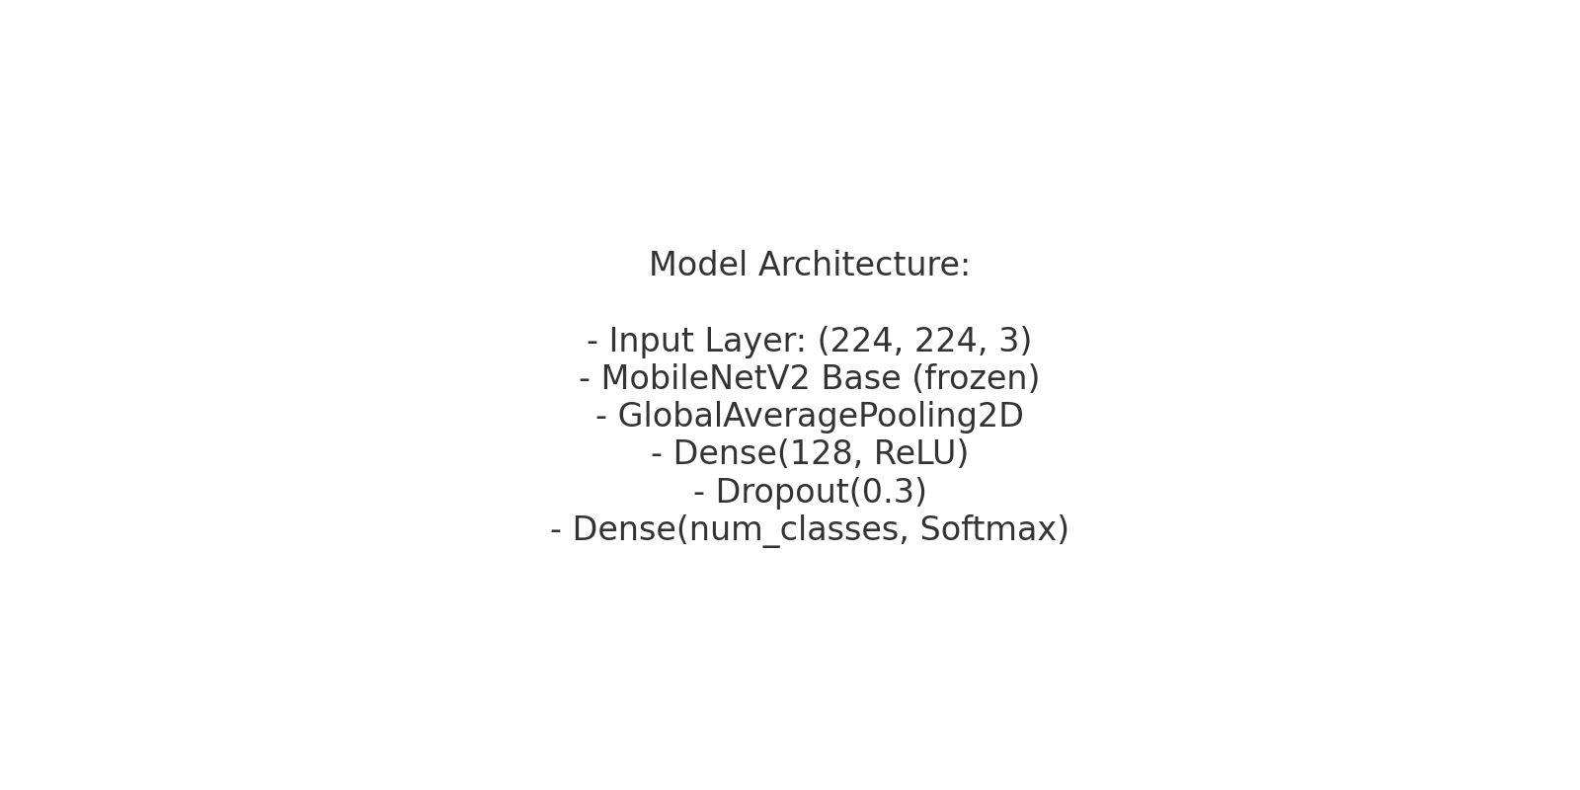
2. Training Curves: Displays model accuracy and loss plots across epochs for both training and validation datasets.

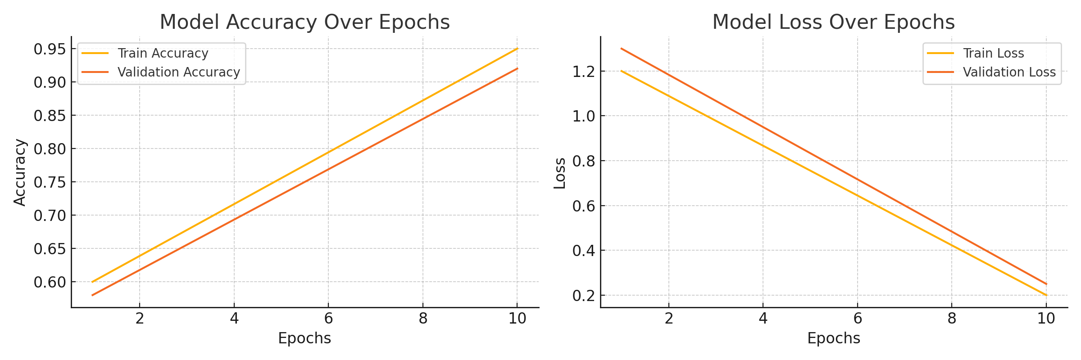

3. Prediction Samples: Example images with predicted disease class labels.
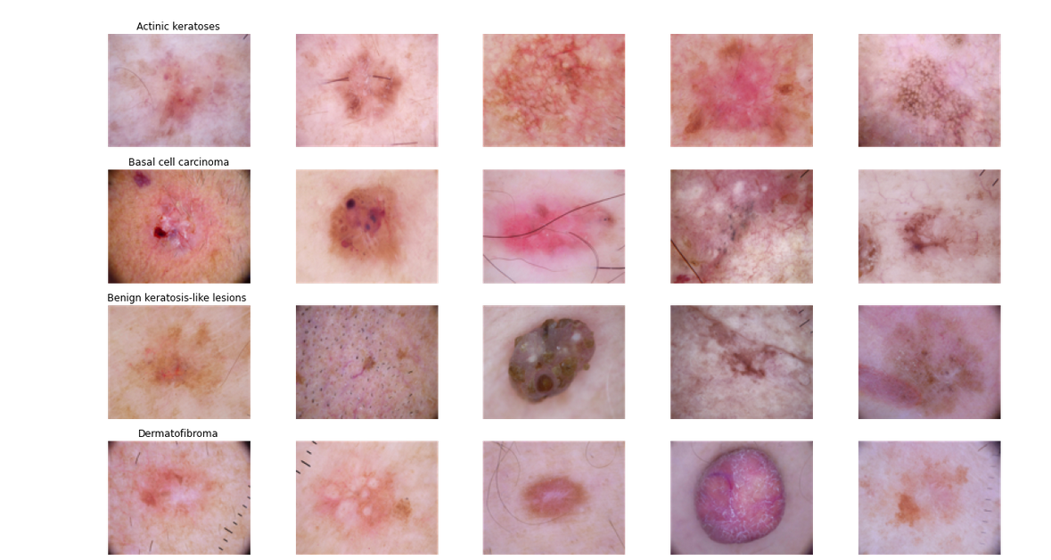

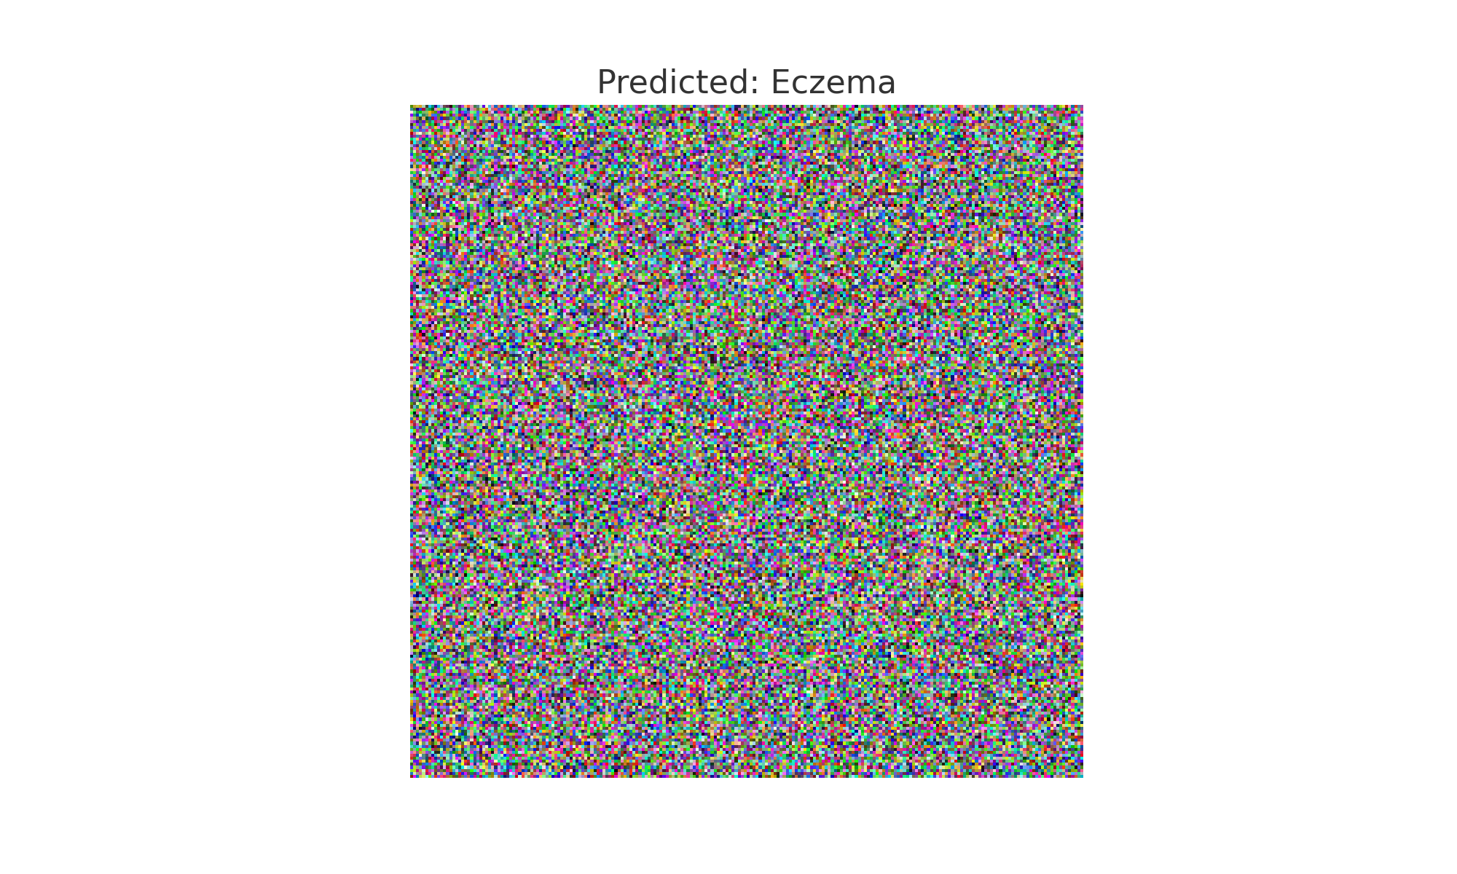

What you learned:

Through this project, I gained practical knowledge of:
- Building custom image classifiers with CNN
- Applying transfer learning to medical datasets
- Handling large image datasets and preprocessing
- Evaluating classification performance

What the Skills you gained:

- Proficient in TensorFlow and Keras API
- Applied deep learning in healthcare domain
- Built and tested transfer learning models
- Performed model evaluation and visualization

Real Time Applications:

- Telemedicine: Quick preliminary diagnostics
- Dermatology Assistants: AI-driven decision support
- Awareness Campaigns: Mobile tools for disease recognition
- Rural Healthcare: Low-cost diagnostic solutions

Further Enhancement Suggestions:

- Create a Streamlit-based web interface for prediction
- Expand dataset for better generalization
- Deploy on mobile apps for field usage
- Integrate with electronic health record (EHR) systems

